# City of Jacksonville Tuesday, April 1, 2025

**12:30 PM**

**117 W. Duval Street** **Jacksonville, FL 32202**

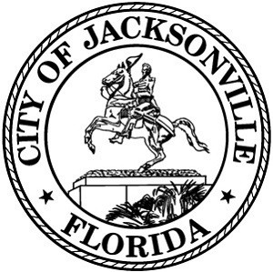**Council Chamber, 1st Floor, City Hall**

**Special Committee on Duval DOGE**

**Agenda**

**April 1, 2025**

**12:30 PM**

**City Council Chamber**

## Call to Order and Introductions

1. Preliminary Discussion on Capital Improvement Plan
2. Discussion on Growth in Departments
3. Questions and Comments
4. Adjourn

Page 1 of 1